The Utilization of High-Frequency Gravitational Waves for Global Communications
Robert M L BAKER, Jr. and Bonnie S. BAKER
Transportation Sciences Corporation and GravWave® LLC
8123 Tuscany Avenue, Playa del Rey, CA 90293

ABSTRACT

For over 1000 years electromagnetic radiation has been utilized for long-distance communication. heliographs, telegraphs, telephones and radio have all served our previous communication needs. Nevertheless, electromagnetic radiation has one major difficulty: it is easily absorbed. In this paper we consider a totally different radiation, a radiation that is not easily absorbed: gravitational radiation. Such radiation, like gravity itself, is not absorbed by earth, water or any material substance. In particular we discuss herein means to generate and detect high-frequency gravitational waves or HFGWs, and how they can be utilized for communication. There are two barriers to their practical utilization: they are extremely difficult to generate (a large power required to generate very weak GWs) and it is extremely difficult to detect weak GWs. We intend to demonstrate theoretically in this paper their phase-coherent generation utilizing an array of in-phase microelectro-mechanical systems or MEMS resonator elements in which the HFGW flux is proportional to the square of the number of elements. This process solves the transmitter difficulty. Three HFGW detectors have previously been built; but their sensitivity is insufficient for meaningful HFGW reception; greater sensitivity is necessary. A new Li-Baker HFGW detector, discussed herein, is based upon a different measurement technique than the other detectors and is predicted to achieve a sensitivity to satisfy HFGW communication needs.

Keywords: Gravitational waves, communications, Li-Baker detector, microelectromechanical systems, high-frequency gravitational waves.

1. INTRODUCTION

Since the dawn of civilization electromagnetic radiation has been utilized for long-distance communication: heliographs, telegraphs, telephones and radio have all served our previous communication needs. Nevertheless, electromagnetic radiation has one major drawback: it is easily absorbed. In this paper we consider a totally different radiation, a radiation that is not easily absorbed: gravitational radiation. Such radiation, like gravity itself, is not absorbed by earth, water or any material substance. In particular we discuss herein a means to generate and detect high-frequency gravitational waves or HFGWs and how they can be utilized for communication. HFGWs are defined as GWs having frequencies in excess of 100 kHz (Douglas and Braginsky [1]) and long-wavelength GW detectors such as LIGO, Virgo and GEO600 cannot sense HFGWs [2]. Global communications by means of HFGWs would be the ultimate wireless system. HFGW communication would greatly reduce communications costs since it would not require the following:



Since the Nobel Prize winning observations of Hulse and Taylor in the 1970s no one has doubted the existence of gravitational waves. There are two barriers to their practical utilization: they are extremely difficult to generate (a large power required to generate very weak GWs) and it is extremely difficult to detect weak GWs. In the past several decades hundreds of peer-reviewed journal articles have addressed these issues, for example Beckwith [3] and Grishchuk [4]. We intend to demonstrate theoretically in this paper that their generation utilizing superradiance (Scully and Svidzinsky. [5]), which involves a linear double-helix array of in-phase micro-electromechanical systems (MEMS) resonator elements, in which the HFGW flux is proportional to the square of the number of elements, solves the HFGW generation or transmitter difficulty. The use of a new, but well documented in peer-reviewed literature, effect discovered by Fangyu Li (Chongqing University, China, [6]) solves the detection difficulty. This Li-effect is the basis for the very sensitive Li-Baker HFGW detector, designed by Robert Baker and developed jointly by United States and Chinese HFGW research teams. As documented in peer-reviewed literature [7, 8, 9, 10] such a detector has sensitivity more than sufficient to receive the transmitted HFGW signal at a significant distance from the transmitter. Dehnen in Germany showed in an article [11] that HFGWs could be generated in the laboratory, using General Relativity, through the use of crystal oscillators. His work is the basis for an efficient HFGW generator or transmitter. The critical element in Dehnen’s HFGW generator or transmitter had been the large size and power requirements of his crystal oscillators. This difficulty is removed through the use of modern MEMS technology. There have been other challenges to HFGW communications based upon the mistaken belief that GW generators or transmitters can only be designed using spinning rods or the effect described by Gertsenshtein in 1962 [12] and analyzed by Eardley in 2008 in the JASON report [13]. Both of these methods for generating GWs are unsatisfactory and produce negligible GW power.

2. HFGW GENERATORS
(Transmitters)

There exist several sources for HFGWs or means for their generation. The first generation means is the same for gravitational waves (GWs) of all frequencies and is based upon the quadrupole equation first derived by Einstein in 1918.[14] A formulation of the quadrupole that is easily related to the orbital motion of binary stars or black holes, rotating rods, laboratory HFGW generation, etc. is based upon the jerk or shake of mass (time rate of change of acceleration), such as the change in centrifugal force vector with time; for example as masses move around each other on a circular orbit. Figure 1 describes that situation. Recognize, however, that change in force Δf need NOT be a gravitational force (see Einstein, 1918 [14]; Infeld quoted by Weber 1964 [15] p. 97; Grishchuk [16]). Electromagnetic forces are more than 10³⁵ larger than gravitational forces and should be employed in laboratory GW generation. As Weber ([15] p. 97) points out: “The non-gravitational forces play a decisive role in methods for detection and generation of gravitational waves ...” The quadrupole equation is also termed “quadrupole formalism” and holds in weak gravitational fields (but well over 100 g’s), for speeds of the generator “components” less than the speed of light and for the distance between two masses r less than the GW

wavelength. Certainly there would be GW generated for r
greater than the GW wavelength, but the quadrupole “formalism” or equation might not apply exactly. For very small time change Δt the GW wavelength, λ_{GW} = c Δt (where c ~ 3×10⁸ m s⁻¹, the speed of light) is very small and the GW frequency ν_{GW} is high. The concept is to produce two equal and opposite jerks or Δf ‘s at two masses, such as MEMS, a distance 2r apart. This situation is completely analogous to binary stars on orbit as shown in Figs. 1 and 2.
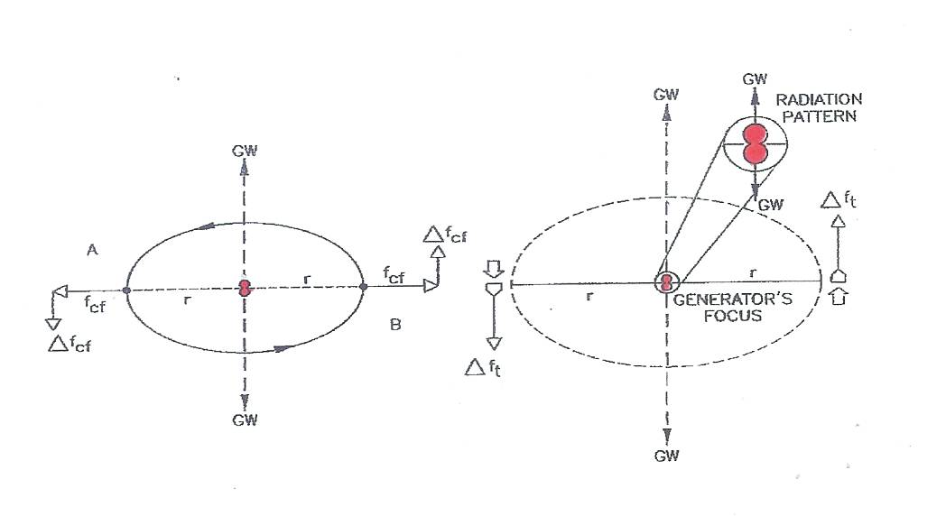
Figure 1. Change in Centrifugal Force of Orbiting Masses, Δf_{cf}, Creates Radiation.

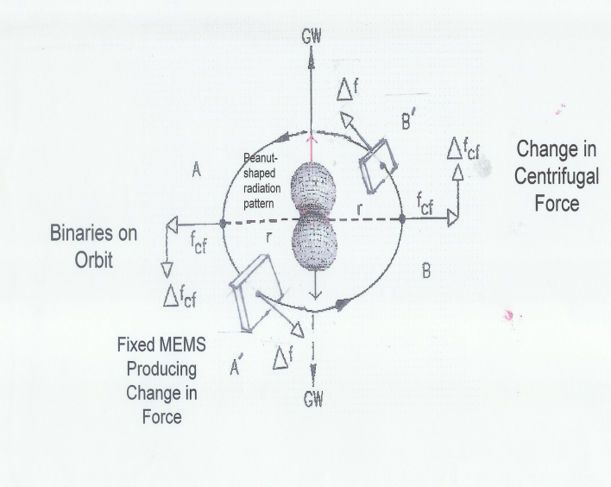
Figure 2. Radiation Pattern Calculated by Landau and Lifshitz [17] Section 110 Page 356.

Next we consider an array of GW sources. Consider a stack of orbit planes, each one involving a pair of masses circling each other on opposite sides of a circular orbit as in Fig. 3. Let the planes be stacked one light hour apart (that is, 60×60×3×10⁸ = 1.08×10¹² meters apart) and each orbit exactly on top of another (coaxial circles). According to Landau and Lifshitz [17] on each plane a GW will be generated that radiates from the center of each circular orbit. The details of that generation process are that as the masses orbit a radiation pattern is generated. In simplified terms (from the equations shown on page 356 of Landau and Lifshitz [17]) an elliptically shaped polarized arc of radiation is formed on each side of the orbit plane (mirror images). As the two masses orbit each other 180⁰ the arcs sweep out figures of revolution. Together these figures of revolution become shaped like a peanut as shown in Fig. 2.

The general concept of the present HFGW generator is to utilize an array of force-producing elements arranged in pairs in a cylindrical formation such as a double helix as in Fig. 4. This is analogous to the binary-star arrays of Fig. 3 in which an imaginary cylinder could be formed or constructed from the collection of orbits. As a wavefront of energizing radiation proceeds along the cylindrical axis of symmetry of such a double-helix array, shown in Fig. 4 the force-producing element pairs (such as pairs of film-bulk acoustic resonators or FBARs) are energized simultaneously and jerk, that is they exhibit a third time
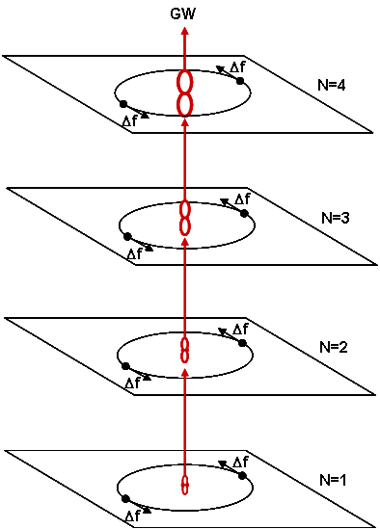

Figure 3. GW Flux Growth Analogous to Stack of N Orbital Planes.

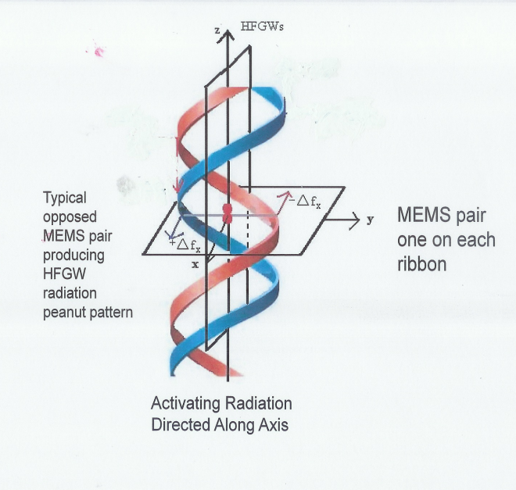
Figure 4. Double-Helix HFGW Generator Array (Patent Pending)

derivative of motion and the flux (W m⁻²) thereby increased. Utilizing General Relativity, Dehnen and Romero-Borja [11] computed a superradiance build up of “… needle-like radiation …” HFGWs beam emanating from a closely packed but very long linear array of crystal oscillators. Their oscillators were essentially two vibrating masses a distance b apart whereas a pair of vibrating FBAR masses is a distance 2r apart as shown in Fig. 5, but operates in an analogous fashion as piezoelectric crystals.

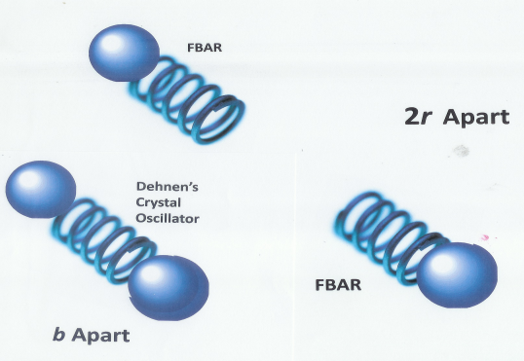

Figure 5. Comparison of Dehnen and Romero-Borja [11] crystal oscillator and FBAR-pair system.

Superradiance also occurs when emitting sources such as atoms “…are close together compared to the wavelength of the radiation …” (Scully and Svidzinsky [5] p.1510). Note that it is not necessary to have the FBAR elements perfectly aligned (that is, the FBARs exactly across from each other) since it is only necessary that the energizing wave front (from Magnetrons in the case of the MEMS or FBARs as in Baker, Woods and Li [18]) reaches a couple of nearly opposite FBARs at the same time so that a coherent radiation source or focus is produced between the two FBARs. The energizing transmitters, such as Magnetrons, can be placed along the helixes’ array axes between separate segments of the array or, more efficiently, at the base of the double helixes so that a superradiance force change, Δf, produced by energizing one off-the-shelf FBAR is 2 N microwave beam is projected up the axis of the helixes. The according to Woods and Baker [19], so that the power is given by the equation derived in Baker [20]:

P = 1.76×10⁻⁵² (2r Δf/Δt)² W. (1)
Let the activating radiation for the FBARs be conventional Magnetrons as employed in one-thousand watt microwave ovens. The frequency would be ν_{EM} = 2.5 GHz (thus ∆t = 4×10⁻¹⁰ s and λ_{EM} = 12 cm). The HFGW frequency is twice that of the activating EM radiation or ν_{GW5} = 5 GHz. For Eq (1) the calculation of the combined ∆f of all the pulsating MEMS or FBARs requires more consideration. We will set the length of a double-helix array cylinder as 20 m, but recognize that it can be separated into segments along the same axis with energizing transmitters, e.g., Magnetrons installed on the cylinder axis between the segments. The transmitters could also be phase coherent and arranged in a line along the double-helix axis at its base. If, for example, there were 1000 one-kilowatt Magnetrons feeding in on one hundred 12-cm, (λ_{EM}, wide levels) and each of their beams covered a 10-cm radius circle, then the energizing radiation flux would be 3.2×10⁴ W m⁻². According to superradiance there would result a needle-like microwave radiation directed along the axis of the double helixes amounting to 32 gigawatts per square meter. In order to create a perfectly planner wave front, with no irregularities, the cylindrically symmetric MEMS array could be contained in a wave guide or possibly a very wide coaxial “cable,” surrounded by a robust one megawatt heat sink. To increase instantaneous power to the array, bursts of gigawatt power, for example, every millisecond could be employed that would maintain a megawatt average power input.

The walls of the cylindrical array are taken to be 30-cm thick. Thus the volume of the twenty meter long array is π(r₁² – r₂²) ×20 m³, where r₁ is the outside radius = 0.35 m and r₂ is the inside radius = 0.05 m. Thus the volume is 7.5 m³. The FBAR is a mechanical (acoustic) resonator consisting of a vibrating membrane (typically about 100×100μm² in plan form, and about 1μm thickness), fabricated using well-established integrated circuit (IC) micro fabrication technology. A typical off-the-shelf FBAR as shown schematically in Fig. 6, usually has overall dimensions 500 µm by 500 µm by approximately 100 µm thick. For our purposes, in which a high number density is important, we will trim the FBARs to a minimum size. In order to account for fabrication margins we will take the dimensions as 110 µm by 110 µm by 20 µm for an FBAR volume of 2.42×10⁻¹³m³.
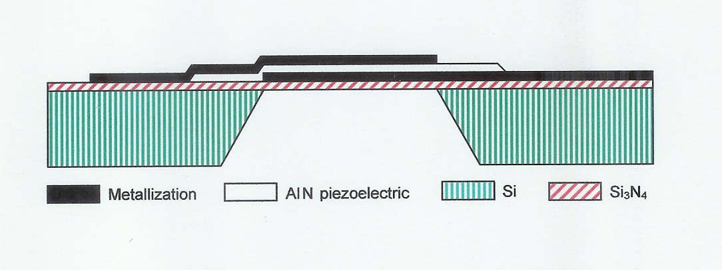
Figure 6. Basic FBAR Construction (cross-section side view, not to scale).

Thus the total number of FBARs in the double-helix cylindrical array is 2.85×10 ¹² and the number of pairs is half of that. There would be N = 1.425×10¹² FBAR pairs in the double-helix cylindrical array. Since each FBAR exhibits a jerking force of 2 N the combined ∆f of all the jerking FBAR pairs is 2.85×10¹² N. if the jerking pairs (or “orbits”) moved in concert. From Eq. (1) the total power produced by the double-helix array is P = 1.76×10⁼⁵²(0.2×2.85×10¹²/4×10⁻¹⁰)² = 3.57×10⁻¹⁰ W. But due to the N levels, each one of which represents an individual GW focus, there exists a “Superradiance” condition in which the HFGW beam becomes very narrow as shown schematically in Fig. B of [5]. Thus the HFGW flux, in W m⁻², becomes much larger at the cap of the radiation pattern. According to the analyses of Baker and Black [21] the area of the half-power cap is given by

A_{cap} = A_{1/2(N=1)} / N m² (2)

A more conservative approach would be that there are N individual GW power sources each with a ∆f = 2 N. Thus from Eq. (1), with 2r_{rms} = 2√[( r₁² + r₂²)/2] = 0.5 m, the total power produced by the double-helix array is P = 1.55×10¹³ ×1.76×10⁻⁵²(0.5×2/4×10⁻¹⁰)² = 1.69×10⁻²⁰ W. But due to the N levels, each one of which represents an individual GW focus, there exists a “Superradiance” condition in which the HFGW beam becomes very narrow as shown schematically in Fig. B of Scully and Svidzinsky [5]. Thus the HFGW flux, in W m⁻², becomes much larger at the cap of the radiation pattern. According to the analyses of Baker and Black [21] the area of the half-power cap is proportional to 1/N and the GW flux is:

S(1) = (P/4)/(1.71/N) = (1.69×10⁻⁻²⁰/4)/ (1.71/1.55×10¹³) = 3.8×10⁻⁸ W m⁻⁻² . (3)

From Baker, et al. [22], Eq. (6A) of the Appendix, the amplitude of the dimensionless strain in the fabric of spacetime is

A = 1.28×10⁻¹⁸√S/ν_{GW} m/m . (4) .

So that at a one-meter distance A = 5×10⁻³² m/m. If the FBARs in all of the helix levels are not activated as individual pairs, then the situation changes. For example, let all of the FBARs in a 6-cm wide level (½ λ_{EM}) be energized in concert. The number of levels would be reduced to N = 20 m/0.06 m = 333. But, because the FBAR-pairs in each level act together, ∆f = (2 N)(1.55×10¹³ / 333). Thus the changes in Eq. (1) cancel out and there is no change in HFGW flux.

The HFGW beam is very narrow. From Eq. (4b) of [21] for N = 1.55×10¹³ it would be sin⁻¹ (0.737)/ √1.55×10¹³ = 1.87×10⁻⁷ radians. For N = 333 the angle is 0.0022 radians. This is still narrow, but the double helix configuration certainly reduces the width of the HFGW beam. Additionally multiple HFGW carrier frequencies can be used with modulation schemes e.g., pulse carrier phase shift key, so the signal is very difficult to intercept, and is therefore useful as a low-probability-of-intercept (LPI) signal, even with widespread adoption of the HFGW technology.

From Woods, et al. [23] the current estimated sensitivity of the Chinese Li-Baker HFGW Detector is A = 1.0×10⁻³⁰ m/m to 1.0×10⁻³² m/m with a signal to noise ratio of over 1500 (Woods, et al [23] p. 511) or if we were at a 1.3x10⁷ m (diameter of Earth) distance, then S = 1.33×10⁻²⁰ Wm⁻². and the amplitude A of the HFGW is given by A = 3.8×10⁻³⁹ m/m. Although the best theoretical sensitivity of the Li-Baker HFGW detector is on the order of 10⁻³² m/m, its sensitivity can be increased dramatically (Li and Baker, [9] by introducing superconductor resonance chambers into the interaction volume (which also improves the Standard Quantum Limit; Stephenson [24]) and two others between the interaction volume and the two microwave receivers. Together they provide an increase in sensitivity of five orders of magnitude and result in a theoretical sensitivity of the Li-Baker detector to HFGWs having amplitudes of 10⁻³⁷ m/m. There also could be a HFGW superconductor lens, as described by Woods [25], which could concentrate very high frequency gravitational waves at the detector or receiver. Thus with Chinese Li-Baker HFGW detector program successful and the Wood’s lens practical, the Li-Baker detector will exhibit sufficient sensitivity to receive the generated HFGW signal globally.

3. HFGW DETECTORS (Receivers)

Operational HFGW Receivers

In the past few years HFGW detectors, as exhibited in Figs. 7, 8 and 9 have been fabricated at Birmingham University, England, INFN Genoa, Italy and in Japan. These types of detectors may be promising for the detection of the HFGWs in the GHz band (MHz band for the Japanese) in the future, but currently, their
sensitivities are orders of magnitude less than what is required. Such a detection capability is to be expected, however, utilizing the Li-Baker detector. Based upon the theory of Li, Tang and Zhao [6] termed the Li-effect, the detector was proposed by Baker during the period 1999-2000, a patent for it was filed in P. R. China in 2001, subsequently granted in 2007 [26.] (http://www.gravwave.com/docs/Chinese%20Detector%20Patent%2020081027.pdf).

Preliminary details were published later by Baker, Stephenson and Li [22]. This detector was conceived to be sensitive to relic HFGWs (or high-frequency relic gravitational waves, termed HFRGWs) having amplitudes as small as 10^{–32} to 10^{–30}, but using resonance chambers to 10⁻³⁷ or possibly smaller [9].

The Birmingham HFGW detector measures changes in the polarization state of a microwave beam (indicating the presence of a GW) moving in a waveguide about one meter across as shown in Fig. 7. (Please see Cruise [27]; and Cruise and Ingley [28].) It is expected to be sensitive to HFGWs having spacetime strains whose amplitudes are A ~ 2 × 10⁻¹³.

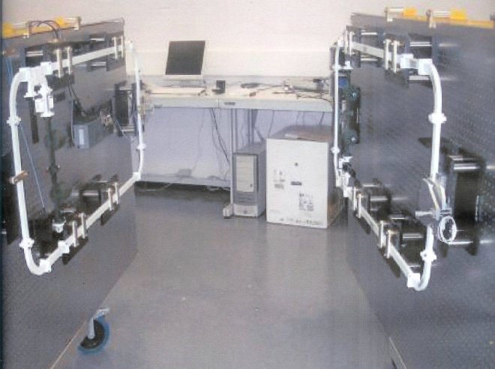

Figure 7 Birmingham University HFGW Detector

The INFN Genoa HFGW resonant antenna consists of two coupled, superconducting, spherical, harmonic oscillators a few centimeters in diameter. Please see Fig. 8. The oscillators are designed to have (when uncoupled) almost equal resonant frequencies. In theory the system is expected to have a sensitivity to HFGWs with size of about A ~ 2×10⁻¹⁷ with an expectation to reach a sensitivity of ~ 2×10⁻²⁰. (Bernard, Gemme, Parodi, and Picasso [29]); Chincarini and Gemme [30]). As of this date, however, there is no further development of the INFN Genoa HFGW detector.

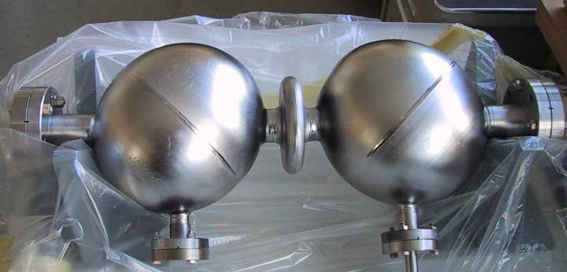

Figure 8 . INFN Genoa HFGW Detector

The Kawamura 100 MHz HFGW detector has been built by the Astronomical Observatory of Japan. It consists of two synchronous interferometers exhibiting an arms length of 75 cm. Please see Fig. 9. Its sensitivity is now about A ≈ 10⁻¹⁶ (Nishizawa et al., [31]). According to Cruise [32]) of Birmingham University its frequency is limited to 100 MHz and at higher frequencies its sensitivity diminishes.

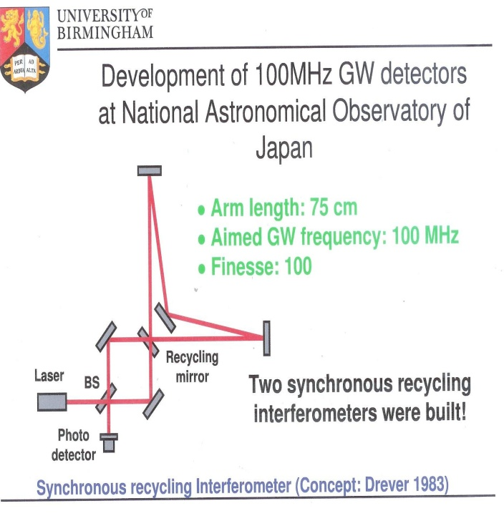
Figure 9. The National Astronomical Observatory of Japan 100MHz Detector. Cruise [31].

Concept (Li-Effect)

The Li-Effect or Li-Theory was first published in 1992 [6]. Subsequently the “Li Effect” was validated by secveral journal articles, independently peer reviewed by scientists well versed in General Relativity, [7, 8, 9, 10] including capstone paper, Li, et al [32]). The reader is encouraged to review the key results and formulas found in Li et al., [10] and the detailed discussion of the coupling among HFGWs, a magnetic field and a microwave beam found in Li et al. [10]. The Li-Effect is very different from the classical (inverse) Gertsenshtein- Effect. With the Li-Effect, a gravitational wave transfers energy to a separately generated electromagnetic (EM) wave in the presence of a static magnetic field. That EM wave has the same frequency as the GW and moves in the same direction. This is the “synchro-resonance condition,” in which the EM and GW waves are synchronized and is unlike the Gertsenshtein-Effect.[12] The result of the intersection of the parallel and superimposed EM and GW beams, according to the Li-Effect, is new EM photons moving off in a direction perpendicular to the beams and the magnetic field directions. These photons signal the presence of HFGWs and are termed a “perturbative photon flux” or PPF. Thus, these new photons occupy a separate region of space (see Fig. 10) that can be made essentially noise-free and the synchro-resonance EM beam itself (in this case a Gaussian beam) is not sensed there, so it does not interfere with detection of the photons. The existence of the transverse movement of new EM photons is a fundamental physical requirement; otherwise the EM fields will not satisfy the Helmholtz equation, the electrodynamics equation in curved spacetime, the non-divergence condition in free space, the boundary and will violate the laws of energy and total radiation power flux conservation. In this connection it should be recognized that unlike the Gertsenshtein effect, the Li-effect produces a first-order perturbative photon flux (PPF), proportional to the amplitude of the gravitational wave . A not A². In the case of the Gertsenshtein-Effect such photons are a second-order effect and according to Eq. (7) of Li, et al. [33] the number of EM photons are “…proportional to the amplitude squared of the relic HFGWs, A²,” … and that it would be necessary to accumulate such EM photons for at least 1.4x10¹⁶ seconds in order to achieve relic HFGW detection (Li et al., [33]) utilizing the Gertsenshtein-Effect. In the case of the Li theory the number of EM photons is proportional to the amplitude of the relic HFGWs, A ≈ 10⁻³⁰, not the square, so that it would be necessary to accumulate such EM photons for less than about 1000 seconds in order to achieve relic HFGW detection (Li et al., [10]). The JASON report (Eardley, [13]) confuses the two effects and erroneously suggests that the Li-Baker HFGW Detector utilizes the inverse Gertsenshtein effect. It does not and does have a theoretical sensitivity that is about A/A² = 10³⁰ greater than that incorrectly assumed in the JASON report for the detection of relic HFGWs.

The Li-Baker HFGW detector operates as follows:

1. The perturbative photon flux (PPF), which signals the detection of a passing gravitational wave (GW), is generated when the two waves (EM and GW) have the same frequency, direction and suitable phase. This situation is termed “synchro-resonance.” These PPF detection photons are generated (in the presence of a magnetic field) as the EM wave propagates along its z-axis path, which is also the path of the GWs, as shown in Figs. 10 and 11.
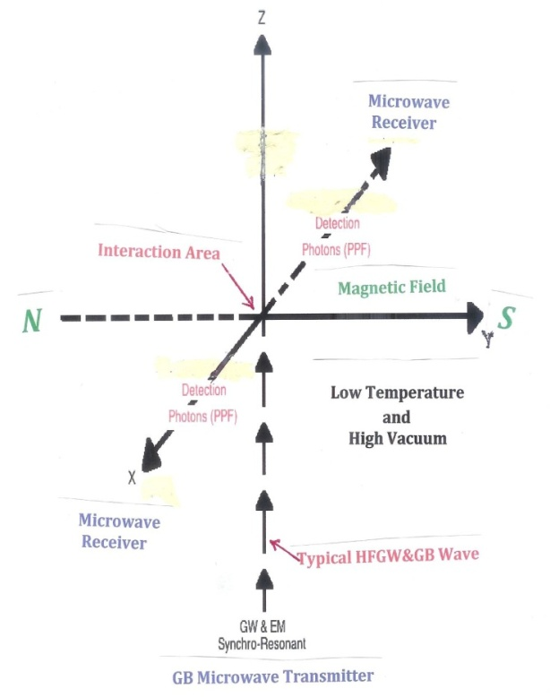
2. The magnetic field B is in the y-direction. According to the Li effect, the PPF detection photon flux (also called the “Poynting Vector”) moves out along the x-axis in both directions.

3. The signal (the PPF) and the noise, or background photon flux (BPF) from the Gaussian beam have very different physical behaviors. The BPF (background noise photons) are from the synchro-resonant EM Gaussian beam and move in the z-direction, whereas the PPF (signal photons) move out in the x-direction along the x-axis and only occur when the magnet is on.

4. The PPF signal can be intercepted by microwave-absorbent shielded microwave receivers located on the x-axis (isolated from the synchro-resonance Gaussian EM field, which is along the z-axis).

.

Figure 10.. Detection Photons Sent to Locations that are Less Affected by Noise.

5. The absorption is by means of off-the-shelf -40 db microwave pyramid reflectors/absorbers and by layers of metamaterial or MM absorbers (Landy, et al. 2008, Woods et al. [23] and Patent Pending) that also seal off out gassing. As discussed in detail by Woods, et al. [23] absorption of about −220 dB or an absorption coefficient of 10⁻²² for the two double MM layers, can be achieved. As noted by Landy, et al. [34] since “…impedance matching is possible, and with multiple layers, a perfect [absorbance] can be achieved.” In addition, isolation is further improved by cooling the microwave receiver apparatus to reduce thermal noise background to a negligible amount as has been accomplished in single-photon receivers (Buller, [35]). In order to achieve a larger field of view and account for any curvature in the magnetic field, an array of microwave receivers having multiple horns (the two receivers having, for example, 12 cm by 12 cm horns (four such horns some two HFGW wavelengths or 2λ_{GW} on a side) could be installed at x = ± 100 cm (arrayed in planes parallel to the y-z plane). As noted in the following Table, all sources of noise in the Li-Baker HFGW detector such as diffraction from the intense Gaussian beam (Woods [36]), dark-background shot noise, signal shot noise, Johnson noise, preamplifier noise, quantization noise, mechanical thermal noise, phase or frequency noise, can be reduced to negligible amounts in a properly designed Li-Baker detector.

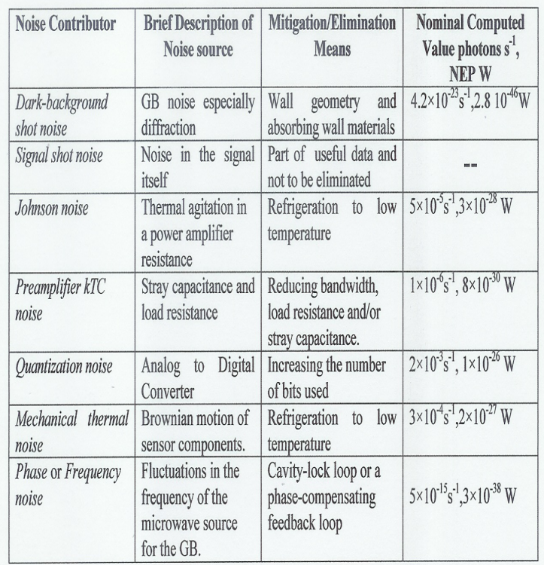

Summary Table of Li-Baker detector noise based upon experimental data concerning its components (Woods et al. [33]).

The total noise equivalent power or NEP is 1.02×10⁻²⁶ W (noise flux is 1.54×10⁻³ photons per second). If need be the receivers could be further cooled and shielded from diffraction noise by baffles and optimum detector geometry as shown in Woods et al. [23]. Given a signal that exhibits the nominal value given in the Summary Table above of Woods et al. [23] of 99.2 s⁻¹ photons, one quarter of which is focused on each of the microwave receivers, which is 24.8 s⁻¹ photons or 1.6×10⁻²² W, the signal-to-noise ratio for each receiver is better than 1500:1 [23].
4. CONCLUSIONS

The utilization of modern MEMS technology and a double-helix array of them would allow for the construction of a HFGW generator or transmitter involving superradiance that exhibits sufficient strength to transmit HFGW signals globally. This is possible even though the conversion rate of EM power to GW power is exceedingly small and, like EM radiation, the GW signal power falls off as the inverse square of the distance. It is shown herein that a properly designed double-helix array of MEMS (or FBARS) can generate sufficient power to reach a receiver on the opposite side of the globe. Three HFGW detectors or HFGW receivers have previously been fabricated and others theoretically proposed, but analyses of their sensitivity suggest that for meaningful HFGW reception, greater sensitivity is necessary. The theoretical sensitivity of the Li-Baker HFGW detector discussed herein, that is based upon a different measurement technique than the other detectors, is predicted to satisfy HFGW communication needs The detector can be built from off-the-shelf, readily available components and, when coupled with the double-helix MEMS or FBAR array transmitter, could provide for transglobal HFGW communications.

Acknowledgments

This research was supported by Transportation Sciences Corporation in the United States and by GravWave® LLC internationally. The assistance of Professor Giorgio Fontana, Trento University, Italy, Professor Fangyu Li, Chongqing University, China and Gary V. Stephenson of LinQuest Corporation, Los Angeles, USA is gratefully acknowledged’

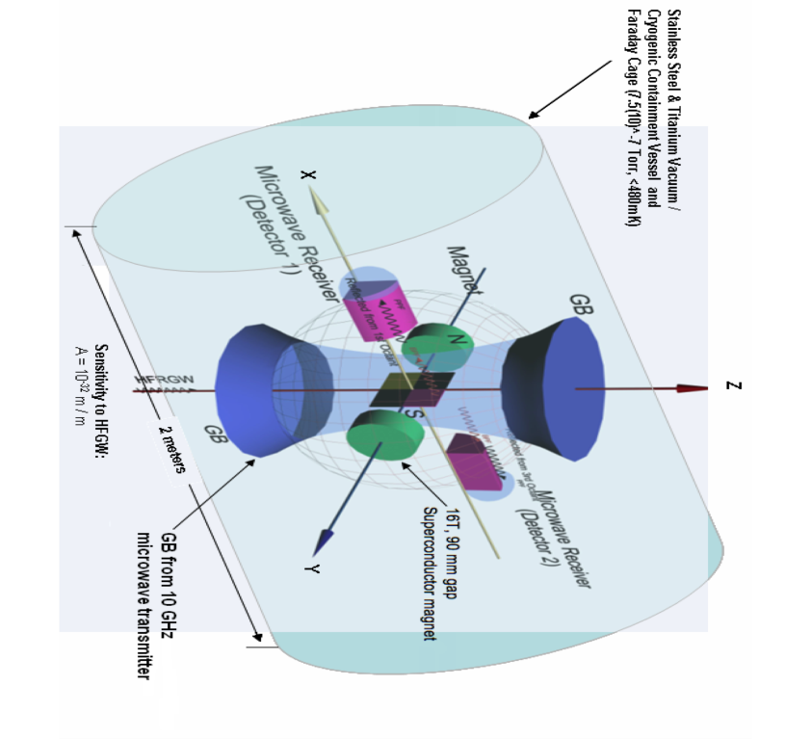

Figure 11. Schematic of Li-Baker HFGW Detector (Peoples Republic of China Patent Number 0510055882.2 [25])

. REFERENCES

[1] Douglass, D.H. and Braginsky, B. (1979), “Gravitational-radiation experiments,” in “General relativity: an Einstein centenary survey” Ed. Hawking S.W. and Israel W. (CUP, UK), 90-137.
[2] Shawhan, P. S. (2004), “Gravitational Waves and the Effort to Detect them,” American Scientist 92, 356.
[3] Beckwith, A. W. (2009), “Relic High Frequency Gravitational waves from the Big Bang, and How to Detect them,” American Institute of Physics Conference Proceedings, Melville, NY 1103, p. 571... . arXiv:0809.1454v1 [physics.gen-ph] (Paper 031).
[4] Grishchuk, L. P. (2003), Gravitational-Wave Conference, The MITRE Corporation, May 6-9..
[5] Scully, M. O. and Svidzinsky, A. A. (2009), “The Super of Superradiance,” Science 325, pp.1510-1511.
[6] Li, F. Y., Tang M. and Zhao P. (1992), “Interaction Between Narrow Wave Beam-Type High Frequency Gravitational Radiation and Electromagnetic Fields,” Acta Physica Sinica 41, pp. 1919-1928.
[7] Li,, F. Y., Meng-Xi Tang, Jun Luo, and Yi-Chuan Li (2000) “Electrodynamical response of a high-energy
photon flux to a gravitational wave,” Physical Review D 62, July 21, pp. 044018-1 to 044018 -9.
[8] Li, F. Y.,, Meng-Xi Tang, and Dong-Ping Shi, (2003), “Electromagnetic response of a Gaussian beam to
high-frequency relic gravitational waves in quintessential inflationary models,” Physical Review B 67, pp. 104006-1 to -17.
[9] Li, F. Y. and Baker, R. M L, Jr. (2007), “Detection of High-Frequency Gravitational Waves by
Superconductors,” International Journal of Modern Physics 21, Nos. 18-19, pp. 3274-3278.
[10] Li F. Y., Baker R. M L, Jr., Fang Z., Stephenson G.V. and Chen, Z. (2008), “Perturbative Photon Fluxes Generated by High-Frequency Gravitational Waves and Their Physical Effects,” European Phys. J. C 22, Nos. 18-19, 30 July; peer reviews and manuscript available at: http://www.gravwave.com/docs/Li-Baker%206-22-08.pdf .
[11] Dehnen, H. and Fernando Romero-Borja (2003), “Generation of GHz – THz High-Frequency
Gravitational Waves in the laboratory,” paper HFGW-03-102, Gravitational-Wave Conference, The MITRE Corporation, May 6-9. Peer reviews and manuscript available at: http://www.gravwave.com/docs/Analysis%20of%20Lab%20HFGWs.pdf.
[12] Gertsenshtein, M. E, (1962), “Wave resonance of light and gravitational waves,”Soviet Physics JETP, Volume 14, Number 1, pp. 84-85.
[13] Eardley, et al. (2008) “High Frequency Gravitational Waves,” JSR-08-506, October, the JASON defense science advisory panel and prepared for the Office of the Director of National Intelligence.
[14] Einstein, Albert, (1918) Über Gravitationswellen. In: Sitzungsberichte der Königlich Preussischen Akademie der Wissenschaften, Berlin (1918), 154–167.
[15] Weber, J. (1964), “Gravitational Waves” in Gravitation and Relativity, Chapter 5, pp. 90-105, W. A. Benjamin, Inc., New York.
[16] Grishchuk, L. P. and Sazhin M. V. (1974), “Emission of gravitational waves by an electromagnetic cavity.” Soviet Physics JETP 38, Number 2, pp. 215-221.
[17] Landau, L. D. and Lifshitz, E. M. (1975), The Classical Theory of Fields, Fourth Revised English Edition, Pergamon Press, pp. 348, 349, 355-357.
[18] Baker, R. M L, Jr., Woods, R. C. and Fangyu Li (2006), “Piezoelectric-Crystal-Resonator High-Frequency Gravitational Wave Generation and Synchro-Resonance Detection,” American Institute of Physics Conference Proceedings, Melville NY 813, pp. 1280-1289. Manuscript available at:
http://www.drrobertbaker.com/docs/AIP;%20HFGW%20Piezoelectric%20Generator.pdf
[19] Woods,, R. C. and Baker, Jr., R. M L (2005), “Gravitational Wave Generation and Detection Using Acoustic Resonators and Coupled Resonance Chambers,” in the proceedings of Space Technology and Applications International Forum (STAIF-2005), edited by M.S. El-Genk, American Institute of Physics Conference Proceedings, Melville, NY 746, 1298.
[20] Baker, R. M L, Jr. (2006) “Novel formulation of the quadrupole equation for potential stellar gravitational-wave power estimation” Astronomische Nachrichten 327, No. 7, pp. 710-713. Peer reviews and manuscript available at: http://www.gravwave.com/docs/Astronomische%20Nachrichten%202006.pdf
[21] Baker, R. M L, Jr. and Black, C. S.(2009), “Radiation Pattern for a Multiple-Element HFGW Generator,” American Institute of Physics Conference Proceedings, Melville, NY 1103. pp. 582-590. Manuscript available at: http://www.drrobertbaker.com/docs/Analyses%20of%20HFGW%20Generators%20and%20Radiation%20Pattern.pdf
[22] Baker, R. M L, Jr., Stephenson, G. V. and Li, F. Y. (2008), “Analyses of the Frequency and Intensity of
Laboratory Generated HFGWs,” American Institute of Physics Conference Proceedings, Melville, NY 969, pp. 1045-1054. Peer reviews and manuscript available at: at: http://www.gravwave.com/docs/Analysis%20of%20Lab%20HFGWs.pdf
[23] Woods, R. C., Baker, Jr. R. M L , Li, F. Y. Stephenson, G. V. Davis, E. W. and Beckwith, A. W. (2011), “A new theoretical technique for the measurement of high-frequency relic gravitational waves,” Journ Mod. Phys. 2, No. 6, pp. 498-518; manuscript available at: . http://www.gravwave.com/docs/J.%20of%20Mod.%20Phys%202011.pdf and abstract available at http://vixra.org/abs/1010.0062.
[24] Stephenson, G. V. (2009) “The standard quantum limit for the Li-Baker HFGW detector,” in the Proceedings of the Space, Propulsion and Energy Sciences International Forum (SPESIF), 24-27 February, Edited by Glen Robertson. (Paper 023), American Institute of Physics Conference Proceedings, Melville, NY 1103 , 542-547; manuscript available at: http://www.gravwave.com/docs/HFGW%20Detector%20Sensitivity%20Limit.pdf

[25] Woods R. C . (2007), “Modified Design of Novel variable focus lens for VHFGW,” in the proceedings of Space Technology and Applications International Forum (STAIF-2007), edited by
M.S. El-Genk, American Institute of Physics Conference Proceedings, Melville, NY 880:1011-1018.
[26] Baker, Jr. R. M L (2001)) Peoples Republic of China Patent Number 01814223.0, “Gravitational Wave Detector,” issued September 19, 2007; patent claims available at: http://www.gravwave.com/docs/Chinese%20Detector%20Patent%2020081027.pdf
[27] Cruise, A. M. (2000), “An electromagnetic detector for very-high-frequency gravitational waves,” Class. Quantum Gravity 17, pp. 2525-2530.
[28] Cruise, A. M. and Ingley, R. M. J. (2005), “A correlation detector for very high frequency gravitational
waves,” Class. Quantum Grav. 22, 5479-5481.
[29] Gemme, B. F.., Parodi, R. and Picasso, E. (2001), “A detector of small harmonic displacements based on two coupled microwave cavities,” Review of Scientific Instruments 72, Number 5, May, pp. 2428-2437.
[30] Chincarini, A and Gemme, G. (2003), “Micro-wave based High-Frequency Gravitational Wave detector,” HFGW-03-103, Gravitational-Wave Conference, The MITRE Corporation, May 6-9.
[31] Nishizawa, A. et al. (2008), “Laser-interferometric detectors for gravitational wave backgrounds at 100 MHz: Detector design and sensitivity,” Phys. Rev. D 77, Issue 2, 022002.
[32] Cruise, A. M. (2008), “Very High Frequency Gravitational Waves,” Gravitational Wave Advanced Detector Workshop (GWADW), Elba Conference, 17 May, slide presentation 132.

[33] Li, F.Y., Yang, N., Fang, Z., Baker, Jr., R. M L, Stephenson, G. V. and Wen, H.,(2009), “Signal photon flux and background noise in a coupling electromagnetic detecting system for high-frequency gravitational waves,” Phys. Rev. D. 80, 060413-1-14; manuscript available at: http://www.gravwave.com/docs/Li,%20et%20al.%20July%202009,%20HFGW%20Detector%20Phys.%20Rev.%20D.pdf
[34] Landy. N. I., Sajuyigbe, S,. Mock, J. J., Smith, D. R. and Padilla (2008), “Perfect Metamaterial Absorber,” Physical Review Letters 100, pp. 207402-1-4, May 23.
[35] Buller, G. S. et al. (2010) ,“Single-Photon Generation and Detection,” Measurement Science and Technology 21, No. 1, pp. 1-28.
[36] Woods, R. C. (2011), “Estimate of diffraction from Gaussian Beam in Li-Baker HFGW detector,” Proceedings of the Space, Propulsion and Energy Sciences International Forum (SPESIF 2011), University of Maryland, Edited by Glen Robertson. (Paper 001); manuscript available at: http://www.gravwave.com/docs/Woods%202010.pdf

